PROGRAMME COMMITTEE

Chair V.I. Klishin, Corresponding Member of the RAS, Doctor of Technical Sciences., Prof. (FRC CCC SB RAS, Kemerovo)

Deputy Chairman L.D. Pavlova, Doctor of Technical Sciences, Prof. (SibSIU, Novokuznetsk)

Members of program committee

S.K. Baimuhametov, Doctor of Technical Sciences, Prof. (Coal Division JSC “ArcelorMittal Temirtau”, Kazakhstan)
Yu.A. Veksler, Doctor of Technical Sciences, Prof. (Marco Systemanalyse und Entwicklung GmbH, Dachau, Germany)
V.N. Zakharov, corresponding member of RAS, Doctor of Technical Sciences, Prof. (IPKON RAS, Russia)
I.V. Zenkov, Doctor of Technical Sciences (Special Designing and Technological Bureau “Nauka” KSC SB RAS, Krasnoyarsk)
V.S. Zykov, Doctor of Technical Sciences, Prof. (VostNII SC, Kemerovo)
A.A. Eremenko, Doctor of Technical Sciences, Prof. (IM SB RAS, Novosibirsk)
Z.R. Ismagilov, Academician of the RAS, Doctor of Chemical Sciences (FRC CCC SB RAS, Kemerovo)
M.G. Mustafin, Doctor of Technical Sciences, Prof. (SPMU, St. Petersburg)
D. Yu. Paleev, Doctor of Technical Sciences (Federal State Enterprise «National mine rescue center», Novokuznetsk)
O.V. Taylakov, Doctor of Technical Sciences, Prof. (VostNII SC, Kemerovo)
V.N. Fryanov, Doctor of Technical Sciences, Prof. (SibSIU, Novokuznetsk)
A.V. Shadrin, Doctor of Technical Sciences, Chief Researcher (FRC CCC SB RAS, Kemerovo)
Clemens Backhaus (Fraunhofer UMSICHT, Oberhausen, Deutschland)
Dr. V. Böspflug (Demeta GmbH, Deutschland)

ORGANIZING COMMITTEE

Chair А.B. Yuriev, Doctor of Technical Sciences, Assoc. Prof. (SibSIU, Novokuznetsk)

Co-Chair Lu Zeng Xiang, Doctor of Technical Science, Professor (USTL, Anshan (China))
Deputy Chairman V.N. Fryanov, Doctor of Technical Sciences, Prof. (SibSIU, Novokuznetsk)

Members of organizing committee

A.N. Domrachev, Doctor of Technical Sciences, Prof. (SibSIU, Novokuznetsk)
V.A. Eremenko, Doctor of Technical Sciences (NUST MISIS, Moscow)
O.I. Kazanin, Doctor of Technical Sciences, Prof. (SPMU, St. Petersburg)
N.A. Kozyrev, Doctor of Technical Sciences, Prof. (SibSIU, Novokuznetsk)
S.M. Nikitenko, Doctor of Economic Sciences, Prof. (FRC CCC SB RAS)
V.Yu. Ostrovlyanchik, Doctor of Technical Sciences, Prof. (SibSIU, Novokuznetsk)
L.D. Pavlova, Doctor of Technical Sciences, (SibSIU, Novokuznetsk)
N.A. Petrik, Candidate of Technical Sciences, (Research and Academic Centre «Kuzbass», Kemerovo)
I.V. Petrov, Doctor of Economic Sciences, Prof. (Financial University, Moscow)
T.V. Petrova, Doctor of Economical Sciences, Prof. (SibSIU, Novokuznetsk)
Yu.E. Proshunin, Doctor of Technical Sciences, Prof. (SibSIU, Novokuznetsk)
V.M. Seryakov, Doctor of Technical Sciences, Prof. (IM SB RAS, Novosibirsk)
V.V. Tabachnikov (Expo center “Kuzbass Fair”, Novokuznetsk)
A.P. Khmelinin, Candidate of Technical Sciences (MI SB RAS, Novosibirsk)

PURPOSES OF THE CONFERENCE:

- development and implementation of science-based technologies for mining of mineral resources;
- development of innovative approaches to creation of high performance equipment for mining industry;
- development of automated control systems, improvement of electro-technical, energy-saving systems of mining industry;
- development of complex extraction technologies and deep processing of mineral resources;
- improvement of industrial and environmental safety at the mining and processing enterprises;
- exchange of domestic and foreign experience in the field of research and development of projects, technologies and equipment.

SECTIONS OF THE CONFERENCE

1. Geotechnologies of complex development of mineral resources
2. Mining machines and transportation systems in mining industry
3. Robotization and automation of mining processes
4. Industrial and environment safety at mining plants

PUBLICATION OF PAPERS

Papers will be published on-line annual journal “Knowledge-based technologies in development and utilization of mineral resources”. The journal has ISSN, UDC and is included in the database of the Russian Science Citation Index, Digital version of the journal will be presented at SibSIU Scientific Library website, and digital scientific library eLibrary.ru.
Articles recommended by the Editorial Board will be published in electronic international scientific journals «E3S Web of Conference», indexed by SCOPUS.

Publication material requirements
For publication in on-line annual journal “Knowledge-based technologies in development and utilization of mineral resources”.
• 8 full page text (page format - A4);
• Text editor - Microsoft Word;
• Mirror margins: top, bottom, outside - 2 cm; inside - 2.5 cm;
• Font - Times New Roman, font size - 12;
• Line spacing – single;
• The first line - UDC (all capital letters, left alignment);
• 1 interval - the article title (all capital letters, bold, centered);
• The following three lines - academic degree, authors Family name, initials; full name of affiliation; city, country (bold, italic, centered);
• 1 interval - Abstract (not more than 5 lines);
• 1 interval - Key words (no more than 8 words or phrases, separated by comma);
• 1 interval - Text of the article (first line indent 1.25 cm, width adjustment).

Page numbering, headers and footers, footnotes are not allowed.

All materials should be submitted not later than
May 1st, 2022

REGISTRATION

To participate in the conference you need to send completed electronic application form and electronic version of paper to the address of the Organizing committee.

Registration form

Name, Surname___________________________________
Academic degree__________________________________
Company position_________________________________
Zip address ______________________________________
Phone___________________________________________
E-mail___________________________________________
Section _________________________________________
Name of report___________________________________
Information about Co-Rapporteurs___________________

Type of report:
plenary
oral
poster

I need:
personal invitation

CONFERENCE SCHEDULE

The date of the Conference: June 7-10, 2022

Conference Venue: Expo Center “Kuzbass Fair”, 654038, Russia, Kemerovo region, Novokuznetsk, 51 Avtotransportnaya Street, Conference room № 3

June 7, 20222 Arrival of the conference participants
June 8, 2022
10⁰⁰-10³⁰ | Registration
10³⁰-13⁰⁰ | Plenary session  Working meeting in sections № 1
13⁰⁰-14⁰⁰ | Break
14⁰⁰-17⁰⁰ | Working meeting in sections № 2
June 9, 2022
10⁰⁰-10³⁰ | Registration
10³⁰-13⁰⁰ | Working meeting of sections № 3
13⁰⁰-14⁰⁰ | Break
14⁰⁰-17⁰⁰ | Working meeting of sections № 4
June 10, 2022 | Summing up the conference

CONTACTS

Applications should be forwarded to the electronic address of Professor Larisa Pavlova:
E-mail: ld_pavlova@mail.ru
Phone: +7 (3843) 46-35-29
Mobile Phone: 8-961-705-3074
Information about Conference can be obtained:
leading specialist in organization of scientific events and exhibition activities Galina Morina:
E-mail: onti@sibsiu.ru
Phone: +7 (3843) 46-26-29
Mobile Phone: 8-908-948-0235

ADDITIONAL SERVICES

Railway and airline reservation services, booking hotels, meeting at the airport and Railway station, organization by Ltd “KuzbassEkspoServis”:
Phone. / Fax: (3843) 32-11-17, 8-923-470-70-06
E-mail: kes_ty@mail.ru
Further information can be obtained:
organizer of scientific congresses of “Kuzbass Fair” Tatyana Vorobyova:
Tel. / Fax: (3843) 32-24-40, 8-923-470-70-01
E-mail: science@kuzbass-fair.ru

Information about the Conference can be obtained on Siberian State Industrial University website at:
http://www.sibsiu.ru/nauka-i-innovacii/konferentsii-seminary-vystavki/urm2022/

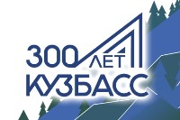 | 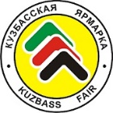 | 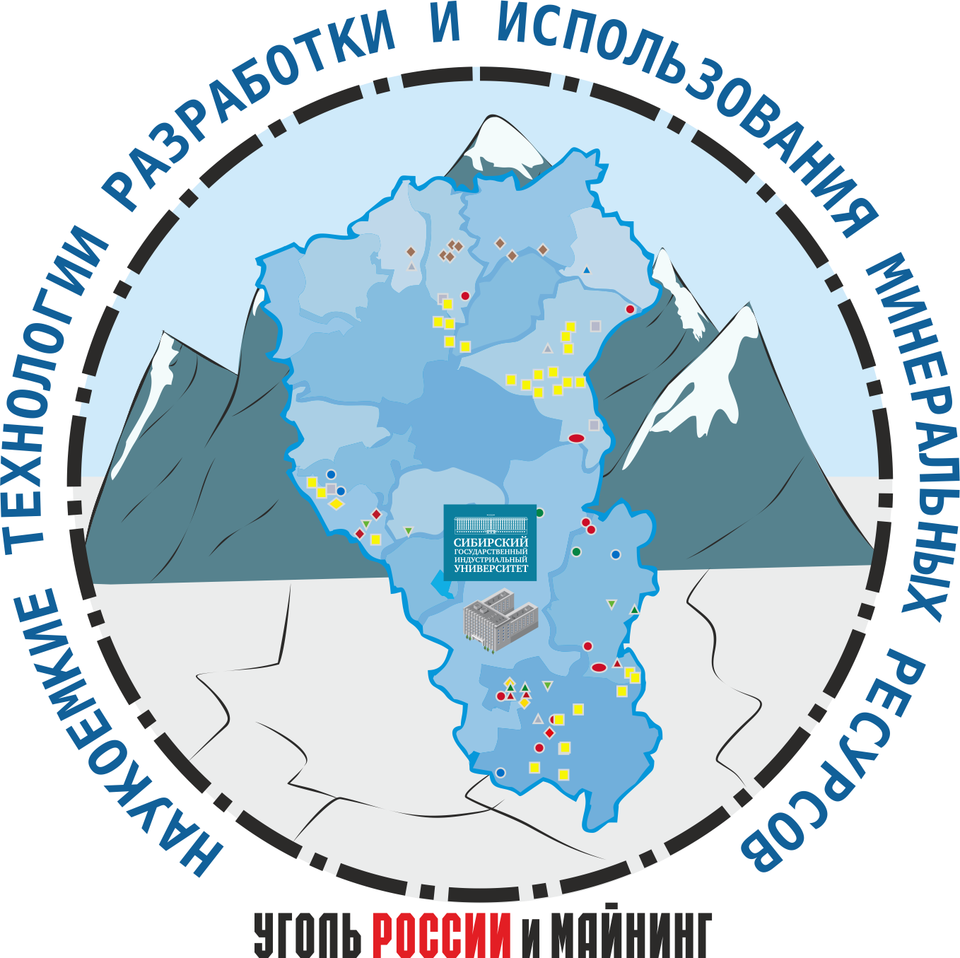 | 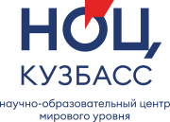
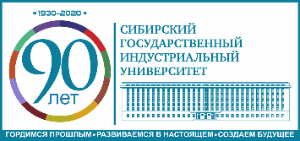

Administration of the Kuzbass Government
Novokuznetsk City Administration
Siberian State Industrial University

Federal Research Center of Coal

and Coal Chemistry SB RAS

VostNII Scientific center on industrial and ecological safety in mining industry

University of Science and Technology Liaoning

Expo center “Kuzbass Fair”

International Scientific and Research Conference on

KNOWLEDGE-BASED TECHNOLOGIES IN DEVELOPMENT
AND UTILIZATION OF MINERAL RESOURCES

within the framework of the international specialized exhibition of coal mining technologies “Coal of Russia and Mining”

June 7-10, 2022

Russia, Novokuznetsk

